EXPERIMENT NO: 2
HOSTEL MANAGEMENT SYSTEM

AIM: To Develop UML diagrams for A Hostel Management System

1. OVERALL DIAGRAM:

USE CASE DIAGRAM:
Use case diagram is a diagram that shows the interaction between user and system to capture the user’s goals.

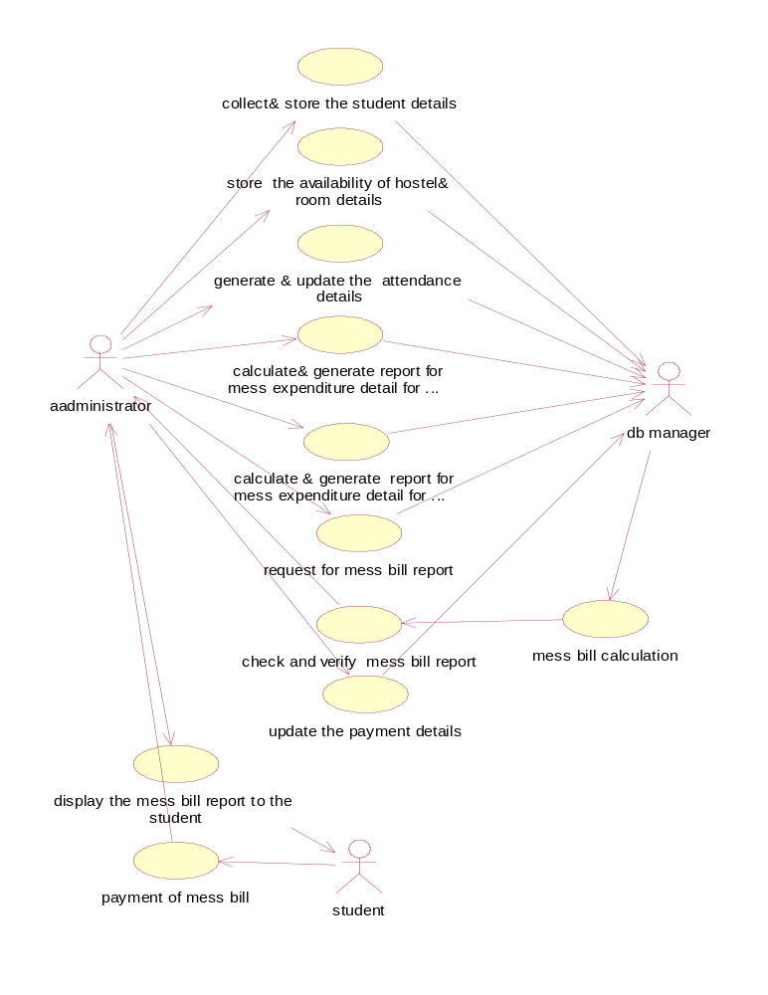

CLASS DIAGRAM:

Class diagram is a collection of static elements such as classes and their relationships connected as a graph to each other.

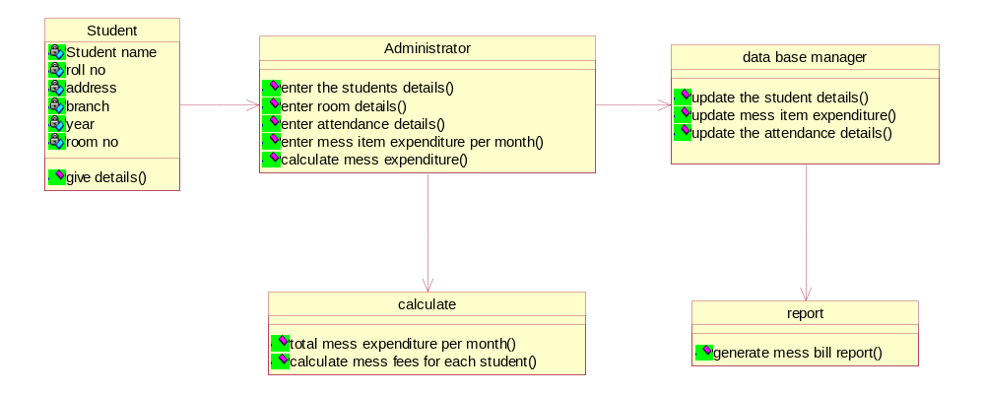

Sequence Diagram:

Sequence diagram shows an interaction arranged in a time sequence . it is an alternate way to understand the overall flow of the control of the system program.

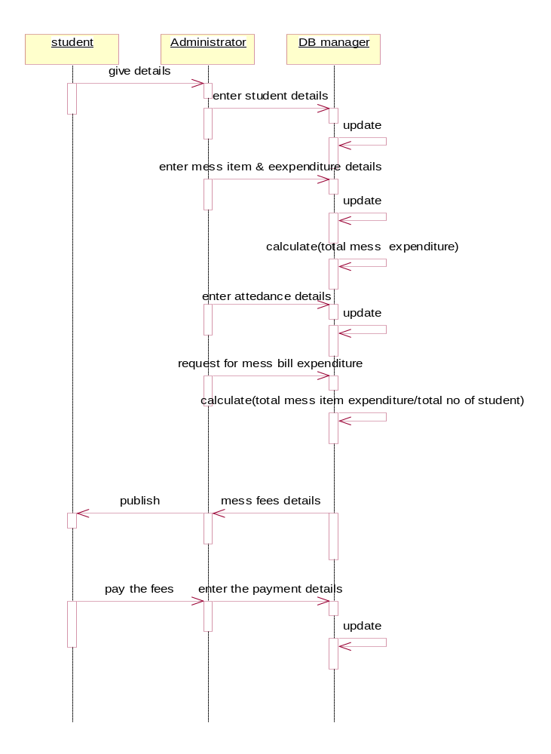

Collaboration Diagram:
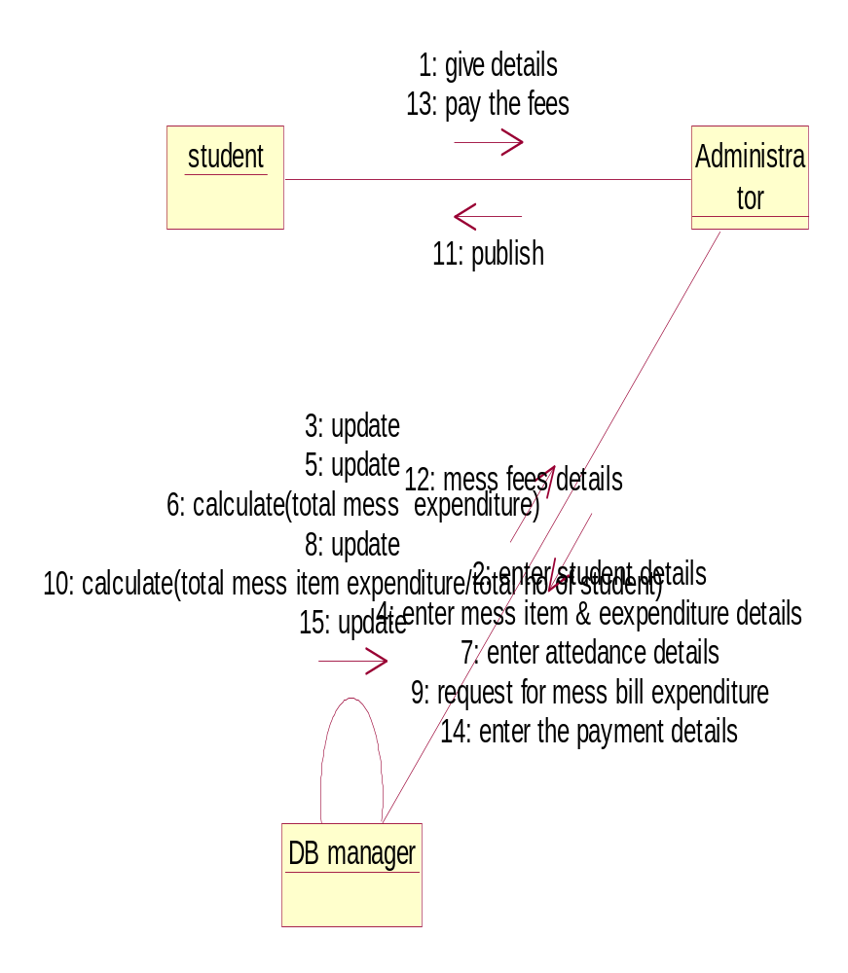

State Diagram:

State diagram are a familiar technique to describe the behaviour of a system. They describe all of the possible states that a particular object can get into and hoe the objects state changes as a result of events that reach the object.

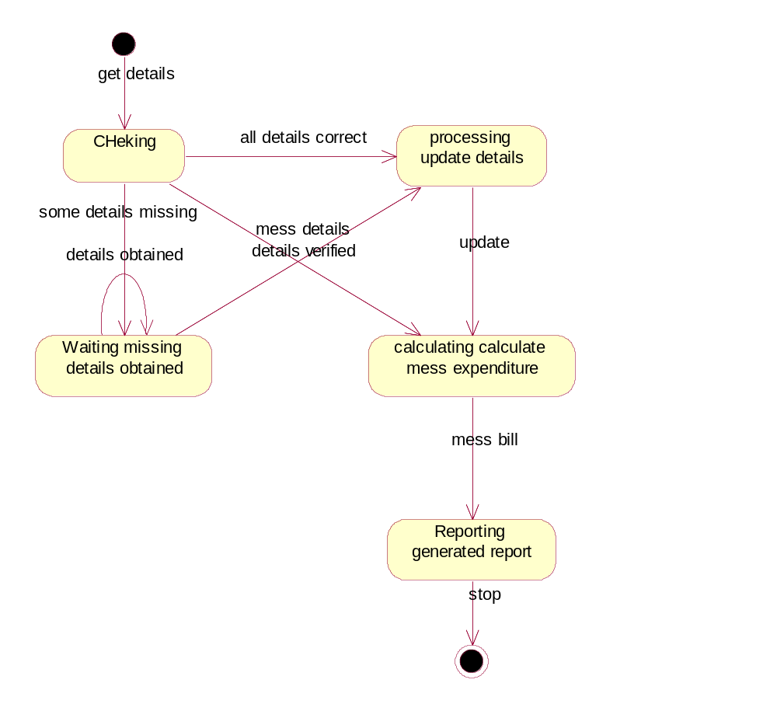

Activity Diagram:

It describes the sequence of activity it support for the conditional and parallel behaviour .
It is a variant of a state diagram in which most of the states are activity states.

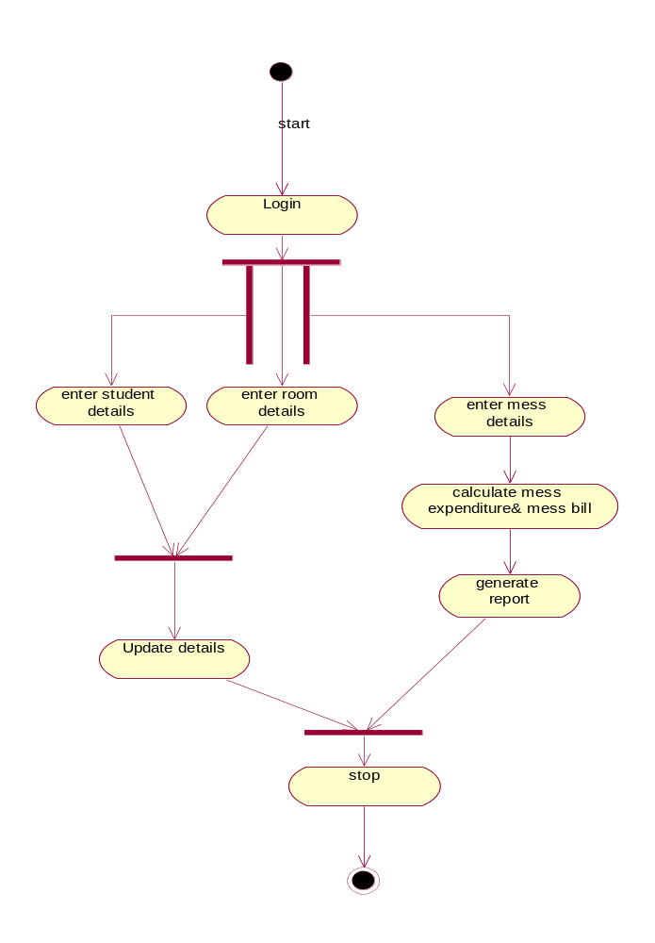

2. METHODOLOGY
USE CASE DIAGRAM:

Use case diagram is a diagram that shows the interaction between user and system to capture the user’s goals.

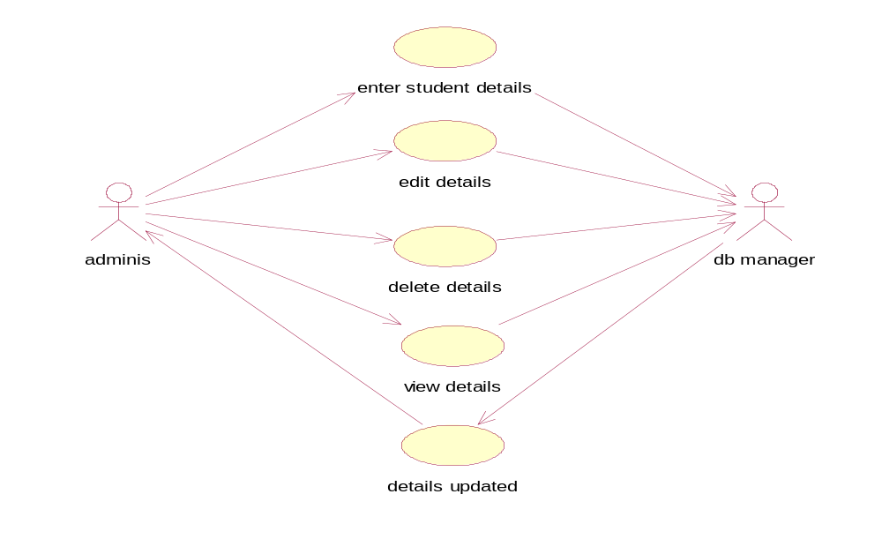
CLASS DIAGRAM:

Class diagram is a collection of static elements such as classes and their relationships connected as a graph to each other.

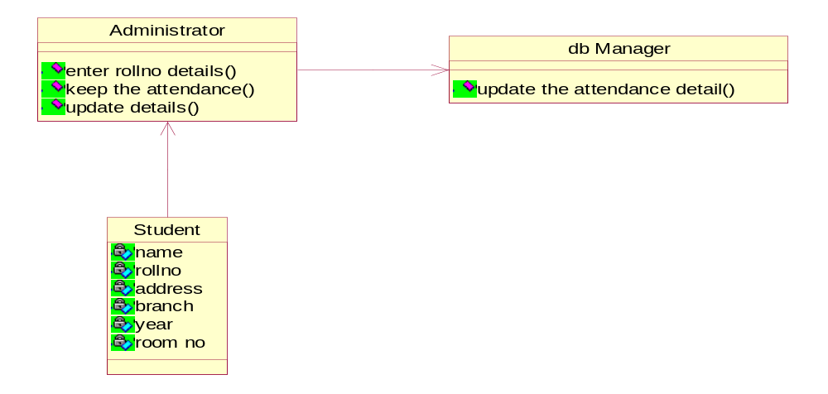

Sequence Diagram:

Sequence diagram shows an interaction arranged in a time sequence . it is an alternate way to understand the overall flow of the control of the system program.

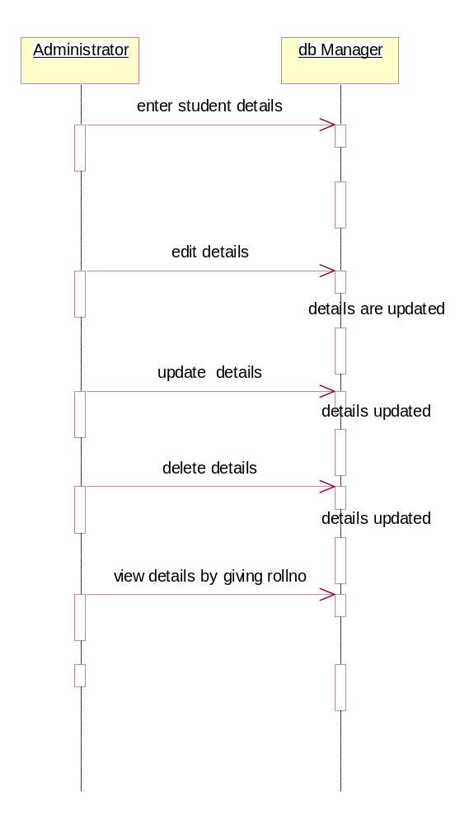

Collabration Diagram:
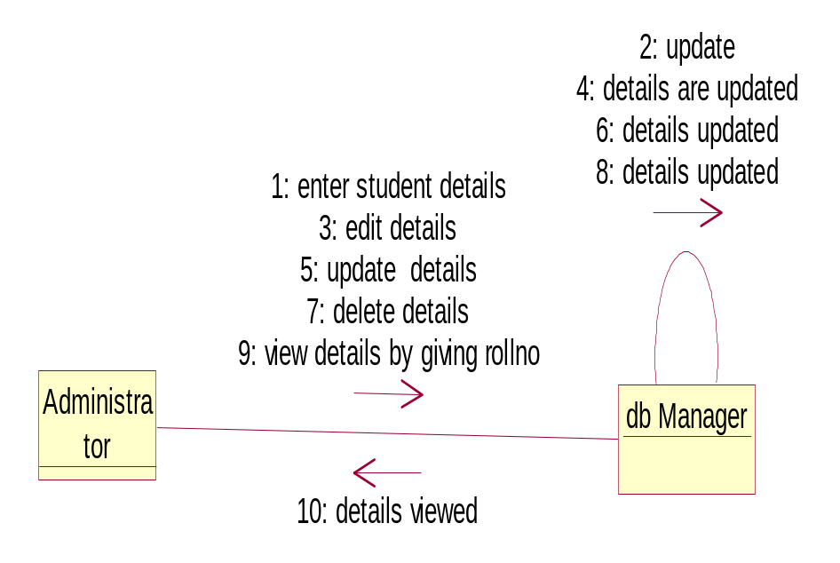

State Diagram:

State diagram are a familiar technique to describe the behaviour of a system. They describe all of the possible states that a particular object can get into and hoe the objects state changes as a result of events that reach the object.

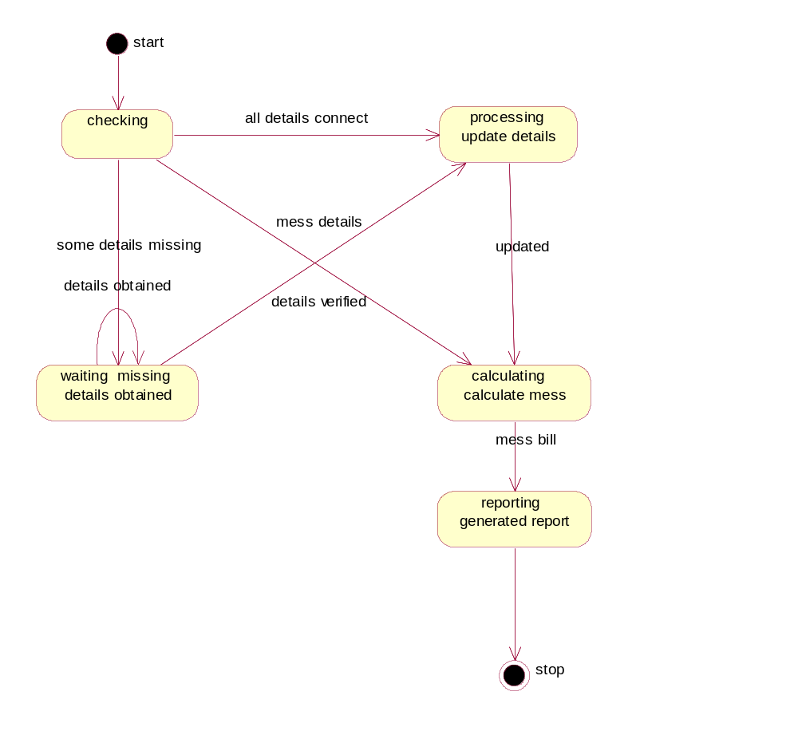

Activity Diagram:

It describes the sequence of activity it support for the conditional and parallel behaviour .
It is a variant of a state diagram in which most of the states are activity states.

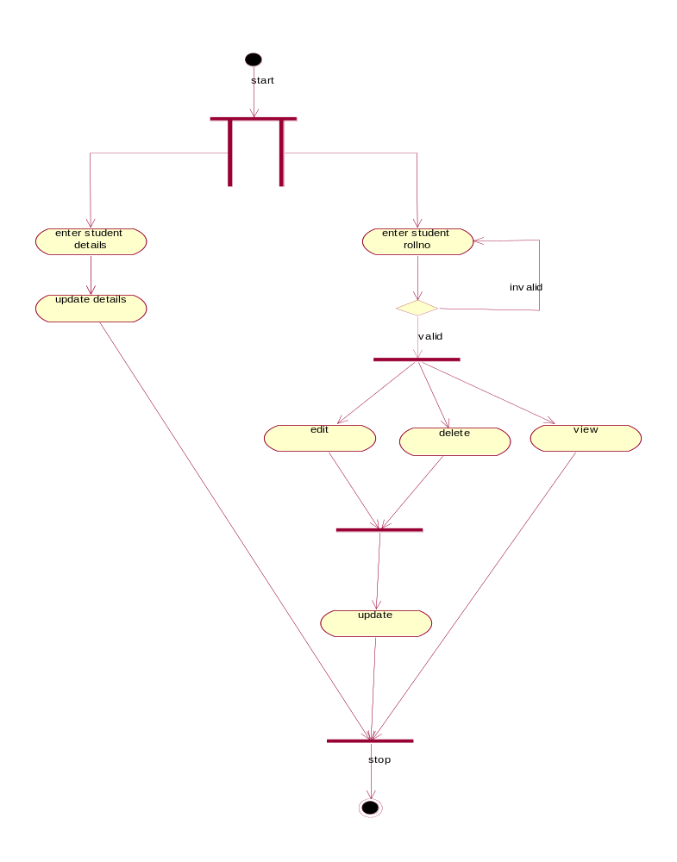

3. ATTENDANCE DETAILS:

In this module, attendance details are maintained.

USE CASE DIAGRAM:

Use case diagram is a diagram that shows the interaction between user and system to capture the user’s goals.

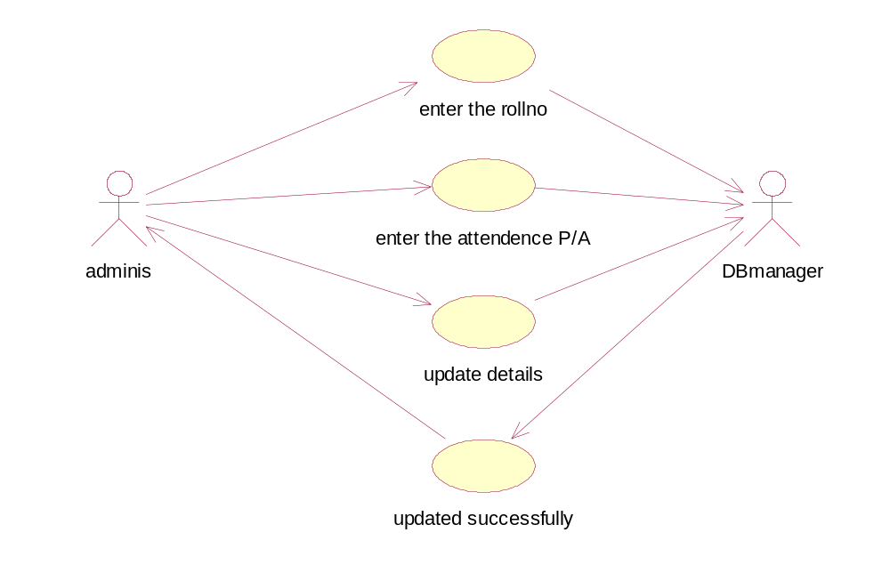

CLASS DIAGRAM:

Class diagram is a collection of static elements such as classes and their relationships connected as a graph to each other.

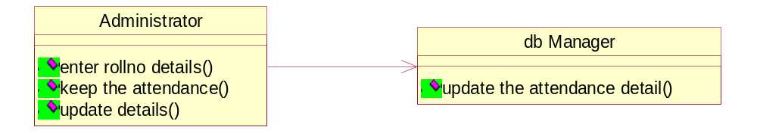

Sequence Diagram:

Sequence diagram shows an interaction arranged in a time sequence . it is an alternate way to understand the overall flow of the control of the system program.

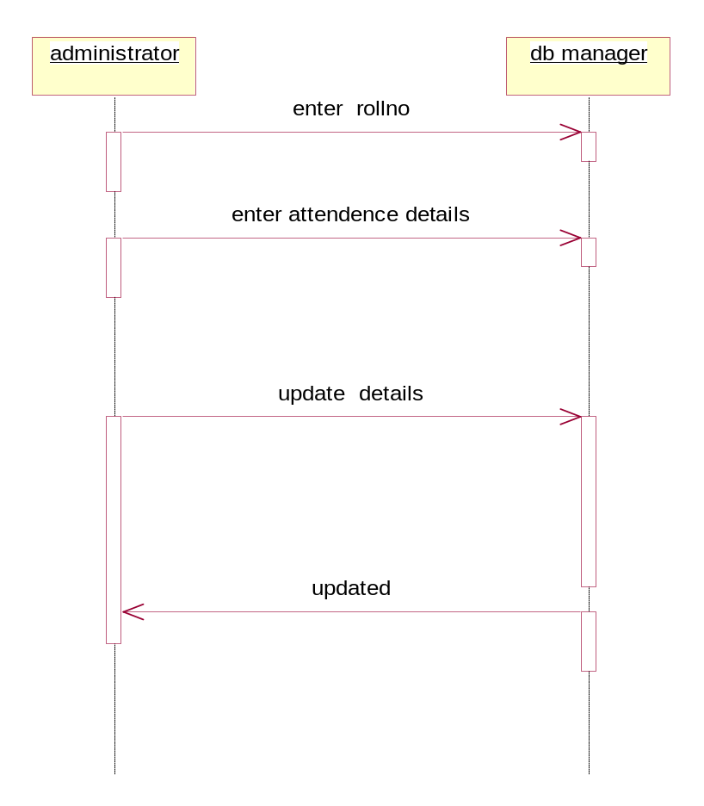

Collabration Diagram:
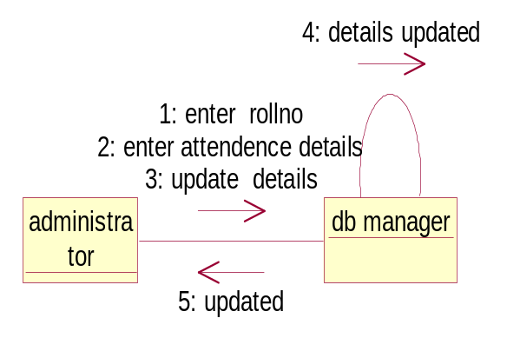

State Diagram:

State diagram are a familiar technique to describe the behaviour of a system. They describe all of the possible states that a particular object can get into and hoe the objects state changes as a result of events that reach the object.

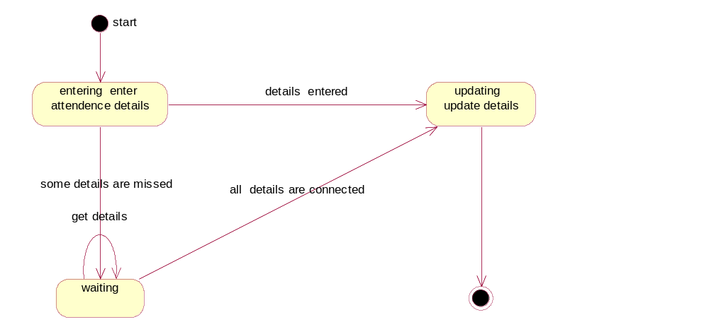

Activity diagram:

It describes the sequence of activity it support for the conditional and parallel behaviour .
It is a variant of a state diagram in which most of the states are activity states.

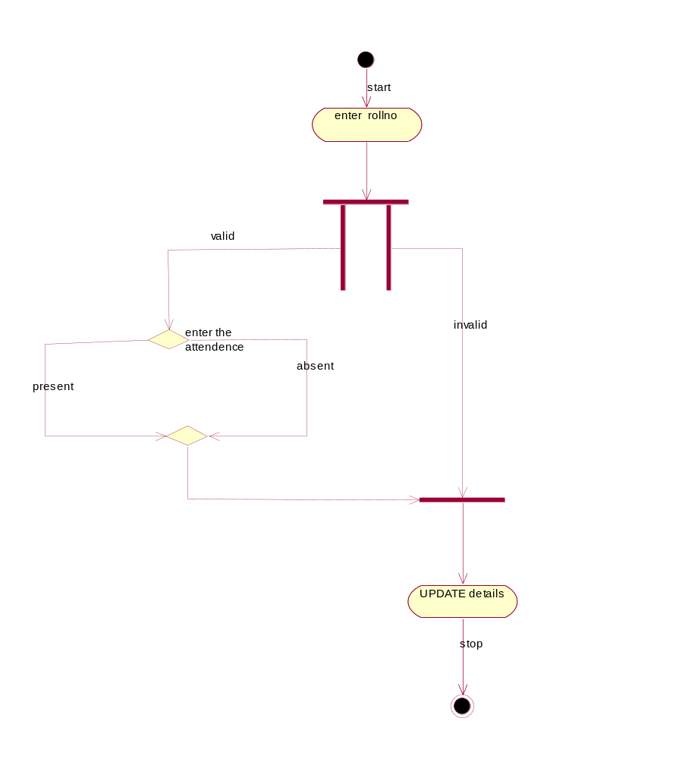

4. ROOM DETAILS:

In this module, the room number for the hostel student is allocated and the details of the each student are maintained and updated regularly.

USE CASE DIAGRAM:

Use case diagram is a diagram that shows the interaction between user and system to capture the user’s goals.

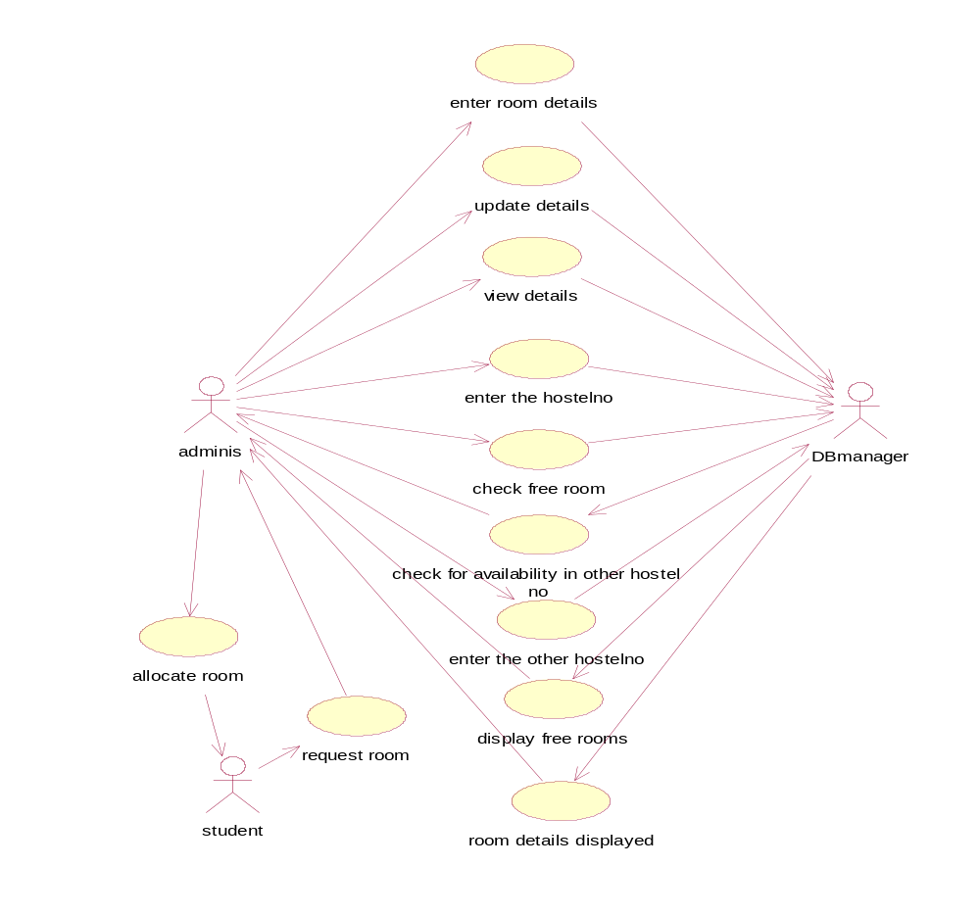

CLASS DIAGRAM:

Class diagram is a collection of static elements such as classes and their relationships connected as a graph to each other.

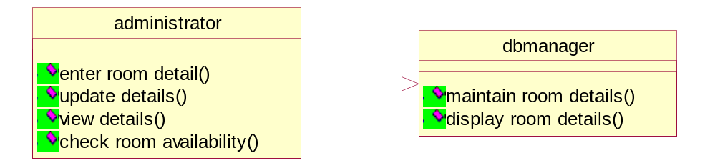

Sequence Diagram:

Sequence diagram shows an interaction arranged in a time sequence . it is an alternate way to understand the overall flow of the control of the system program.

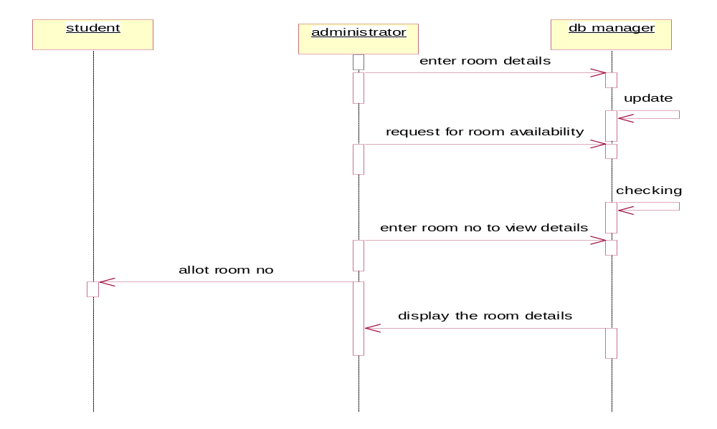

Collabration Diagram:
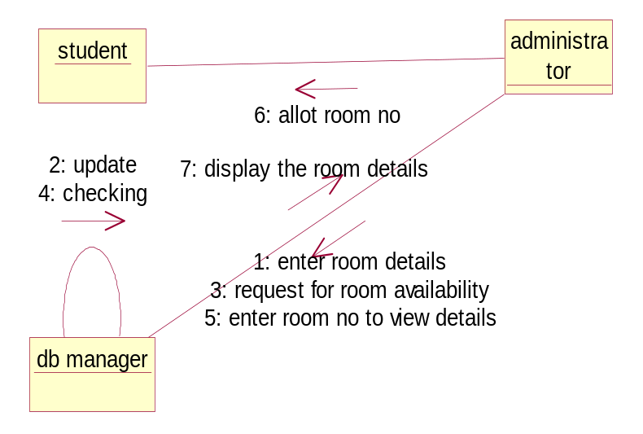
State Diagram:

State diagram are a familiar technique to describe the behaviour of a system. They describe all of the possible states that a particular object can get into and hoe the objects state changes as a result of events that reach the object.

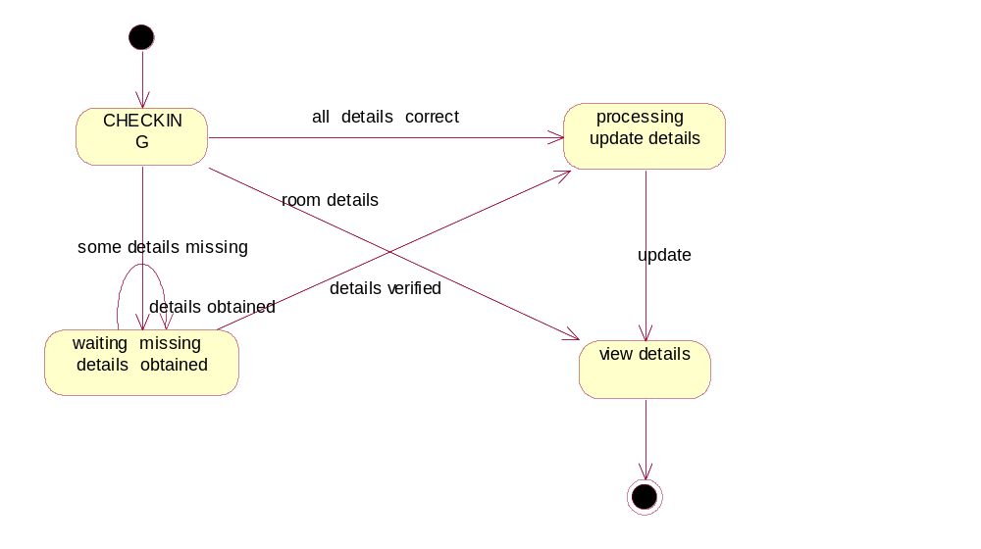

Activity Diagram:

It describes the sequence of activity it support for the conditional and parallel behaviour .
It is a variant of a state diagram in which most of the states are activity states.
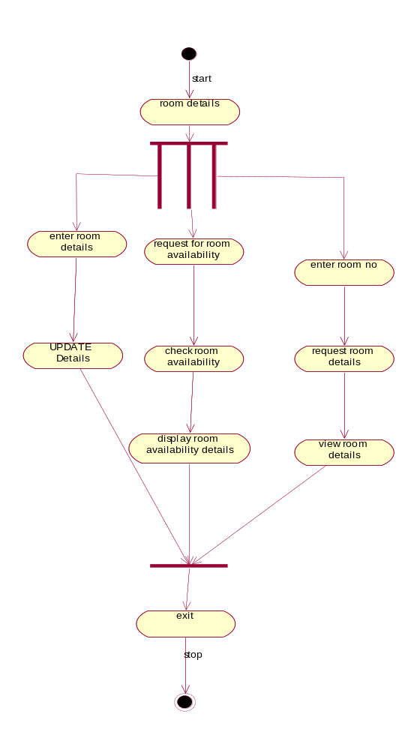

5MESS MODULES:

In this module, the mess item expenditure for each student in the hostel is calculated for each month and the mess bill for each student in calculated and displayed.

USE CASE DIAGRAM:

Use case diagram is a diagram that shows the interaction between user and system to capture the user’s goals.

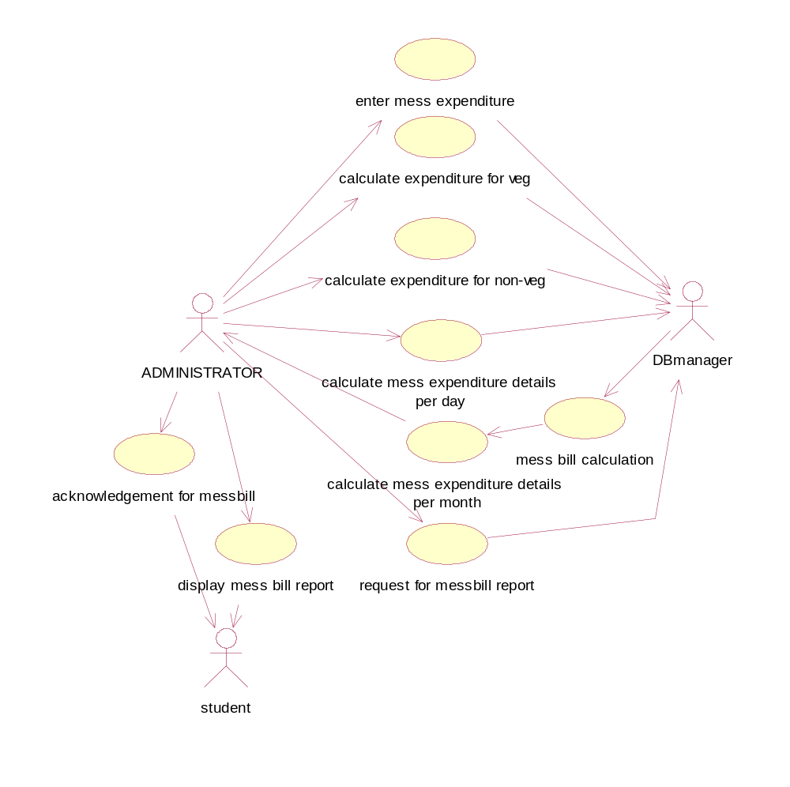

CLASS DIAGRAM:

Class diagram is a collection of static elements such as classes and their relationships connected as a graph to each other.

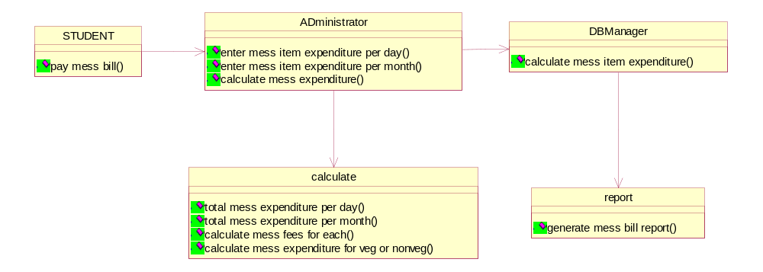

Sequence Diagram:

Sequence diagram shows an interaction arranged in a time sequence . it is an alternate way to understand the overall flow of the control of the system program.

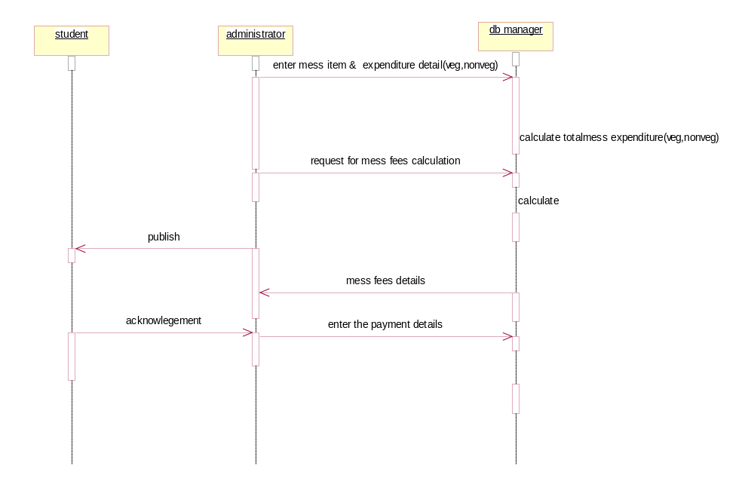

Collaboration Diagram:
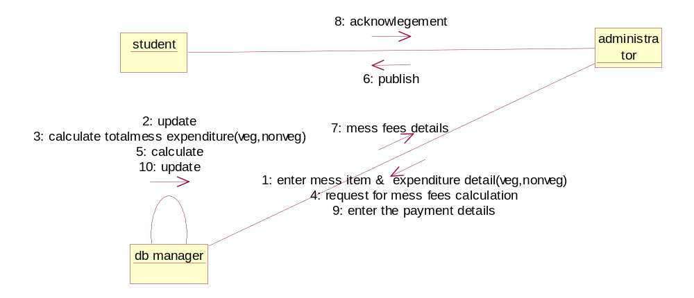
State Diagram:

State diagram are a familiar technique to describe the behaviour of a system. They describe all of the possible states that a particular object can get into and hoe the objects state changes as a result of events that reach the object.

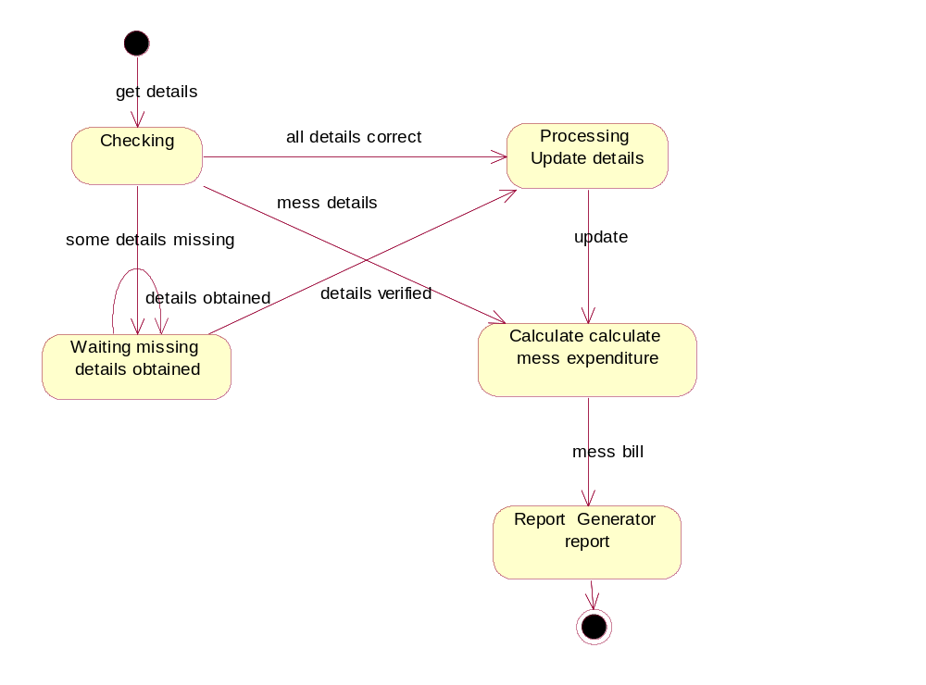

Activity Diagram:
It describes the sequence of activity it support for the conditional and parallel behaviour .
It is a variant of a state diagram in which most of the states are activity states.

